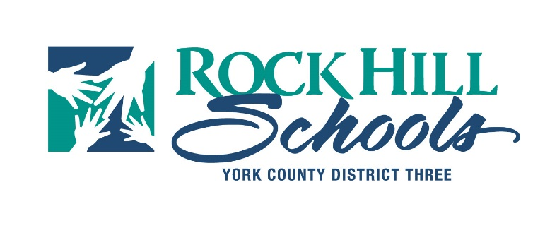

Procurement Services

Lee Faris

386 East Black Street T: (803) 981-1162

Rock Hill, SC 29731 www.rock-hill.k12.sc.us

Dr. Tommy Schmolze, *Superintendent*

# **STATEMENT OF AWARD**

**Award Posting Date: October 10, 2022**

**Bid/RFP/RFQ Number:** 22-2303

**Description:** Metal Roof Pole Shelter at RHHS

**Advertisement Date:** September 15, 2022

**SCBO Advertisement Date:** September 15, 2022

**Date of Opening/Closing:** October 5, 2022

**AWARD IS MADE TO THE FOLLOWING:**

**Contract Building Systems LLC**

**114 Bunker Dr**

**West Columbia, SC 29172**

**$62,575.00**

## **THIS IS NOT AN ORDER**

**DO NOT INCUR COST PRIOR TO RECIEPT OF PURCHASE ORDER**

**All protests shall be in accordance to Rock Hill Schools Consolidated Procurement Code Section 4210 which can be viewed** <https://www.rock-hill.k12.sc.us/Page/6139>.